**Test Case** **0027**

**System:** VirtuCardsClient & VirtuCardsHost

**Description:** Test an anonymous user receives a random username

**Severity:** 2

**Instructions**

**Test 1**

1. Start VirtuCardClient application
2. Click the button labeled “Play Anonymously”
3. Press the Profile button on the top left of the screen

**Expected Result:** A player is able to access game features through an anonymous login attempt (guest user)

**VirtuCard Client:**

Client current anonymous login

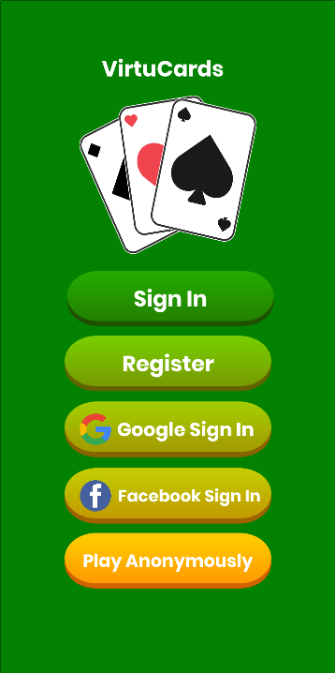

Successful Login

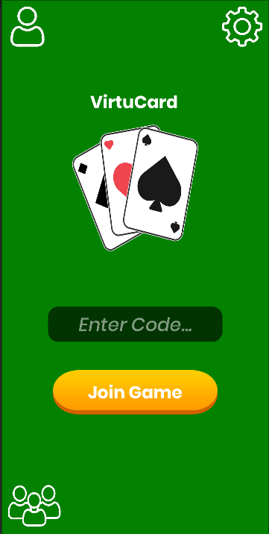

Username visible on profile screen

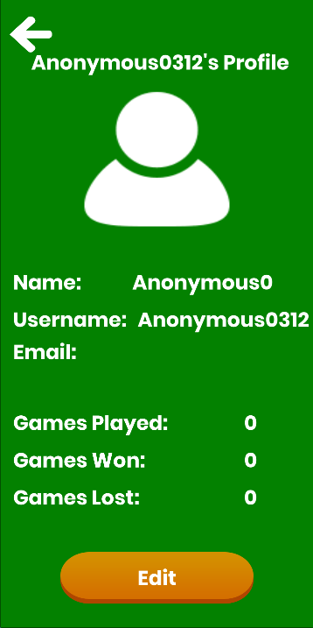

**Test 2**

1. Start VirtuCardClient application
2. Click the button labeled “Play Anonymously”
3. Press the Profile button on the top left of the screen
4. Start another VirtuCardClient application
5. Click the button labeled “Play Anonymously”
6. Press the Profile button on the top left of the screen

**Expected Result:** Both anonymous clients should have unique usernames displayed on the profile screen.

**VirtuCard Client 1:**

Username visible on profile screen

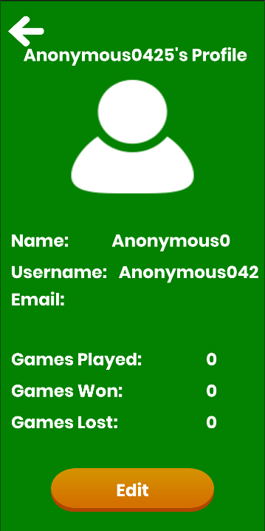

**VirtuCard Client 2:**

Username visible on profile screen

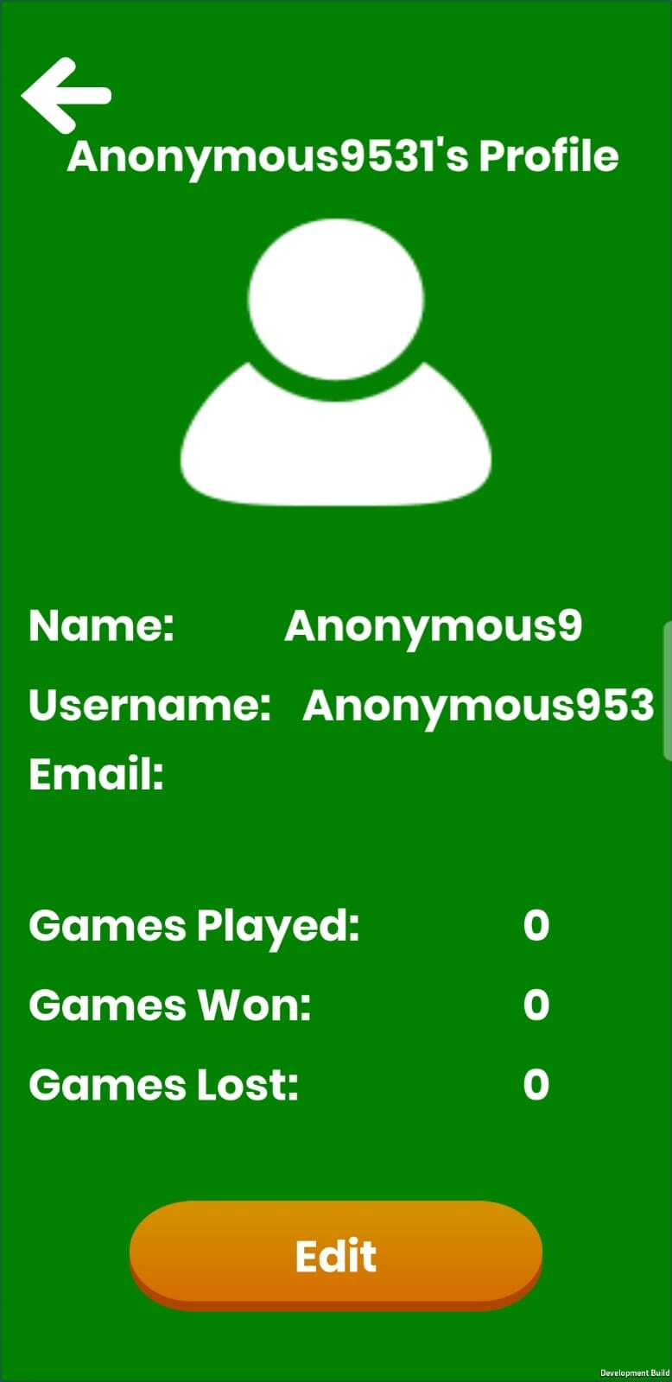

**Test 3**

1. Start VirtuCardClient application
2. Click the button labeled “Play Anonymously”
3. Press the Profile button on the top left of the screen
4. Start another VirtuCardClient application
5. Click the button labeled “Play Anonymously”
6. Press the Profile button on the top left of the screen
7. Start VirtuCardHost application
8. Click the button labeled “Sign In”
9. Enter “virtucards01@gmail.com” into the text input labeled “Enter email…”
10. Enter “Testing1” into the text input labeled “Enter password…”
11. Press the button labeled “Login”
12. A window should appear saying “Login Success”
13. Press the OK button that appears on that window
14. Select the “GoFish” option from the game choices dropdown
15. Press the Create Game button
16. On the VirtuCardClient application enter the 6-character room code found on the host’s screen into the field labeled “Enter Code…”
17. Press the Join Game button on the client
18. On the waiting screen on the VirtuCardHost application and observe the name of the players in the game
19. Press the Start Game button on the host

**Expected Result:** The unique names of the anonymous clients are reflected across the UI and during the game.

**VirtuCard Host:**

Unique anonymous usernames are present on the waiting screen

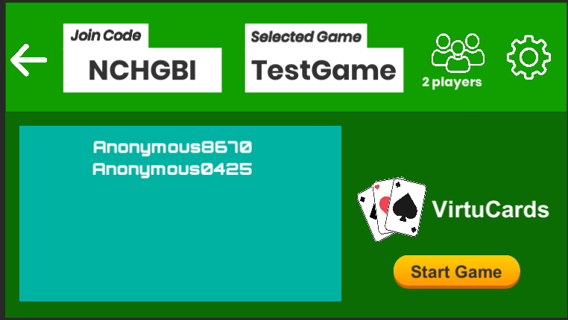

Profile icons shown with anonymous unique usernames

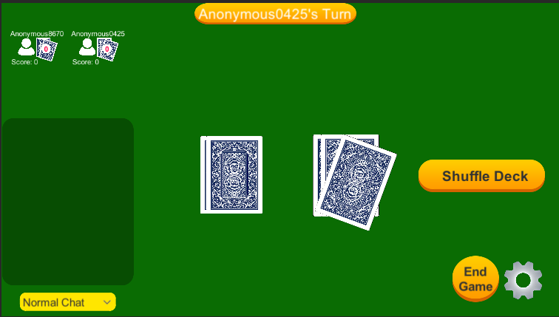

**VirtuCard Client:**

Game status updates and chat are also labelled with the unique anonymous usernames

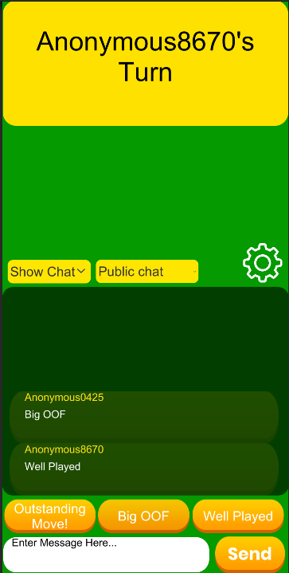

**Test 4**

1. Start VirtuCardClient application
2. Click the button labeled “Play Anonymously”
3. Press the Settings button on the top right of the screen
4. Click the Exit Game button in the Settings menu

**Expected Result:** The anonymous user’s client closes and their profile is deleted from Firebase

**VirtuCard Client:**

Exit Game is available

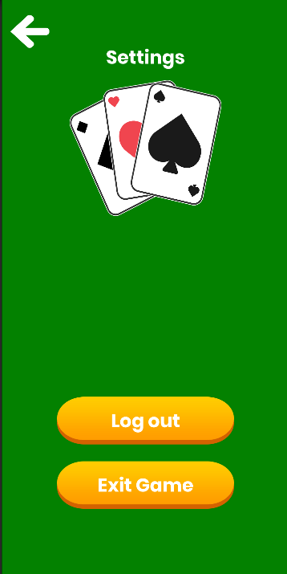

**Firebase:**

List of users sorted by most recent sign in

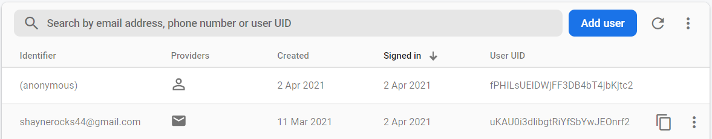

The most recent sign in is the anonymous user

After exiting the game:

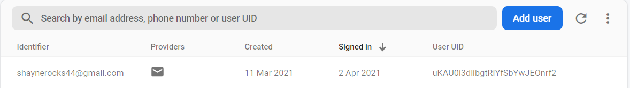

The most recent sign in is a known user as the account of the anonymous player has been successfully removed from the user database.